**Computer Networking**

**Lab 6**

**Due Date: Check blackboard**

**Dr. Abraham**  
Ethical Hacking

Hackers identify weakness in computer hardware or software to gain access. Hackers attempt to gain access to steal or corrupt data or hold data for ransom. They accomplish this through ransomware, spyware, key loggers, etc. Ethical Hacking is to learn how hackers gain access and to prevent future hacking from intruders.

Ethical hackers can use various tools including. There are both Linux and Windows based tools, many free to download. Most widely used operating system for ethical hacking is Linux. Kali Linux distribution (previously known as Backtrack) is used widely to conduct penetration testing.

Expanding dropdown applications menu in Kali Linux gives 14 applications that an Ethical Hacker can use (for example, Information Gathering, Database Assessment, Password Attacks, Forensics, etc). For this assignment please choose **any three** you would like and show proper usage and submit screen captures. Alternatively, you can choose to do any two from Kali Linux and choose Windows or smartphone hacking.

It is my hope different individuals in class will use different applications and perform different examples, so we can get more complete picture of what Kali Linux can do.

**This would be a lab which I would ask you present in class**. Please work on it early and be ready.

Example 1. Find IP addresses of all Kali domains, subdomains and IP address, using recon-ng

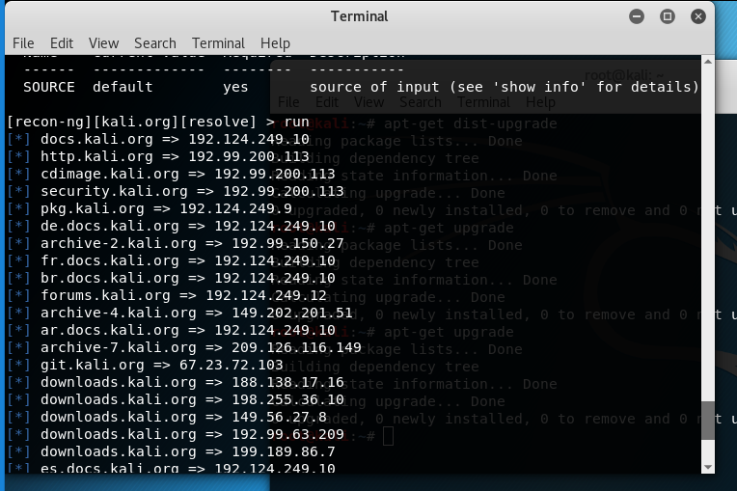

Example 2: find password for root using password hacking utility.

